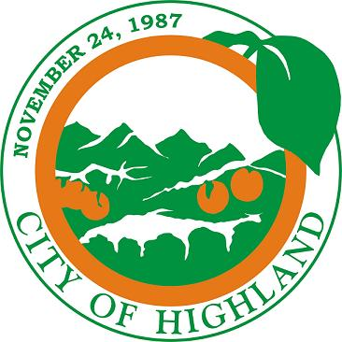
CITY OF HIGHLAND

NOTICE OF AVAILABILITY
REQUEST FOR PROPOSALS

A REQUEST FOR PROPOSALS HAS BEEN ISSUED BY THE CITY OF HIGHLAND FOR A TOWING SERVICE ROTATION LIST FOR JANUARY 1, 2024 TO DECEMBER 31, 2025

Subject: Towing Service Rotation List Contract for 2024 and 2025

Issuer: City of Highland

Proposal: The City of Highland has issued a Request for Proposals (RFPs) for a Towing Service Rotation List by local tow companies. The related contract will be a two (2) year contract for calendar years 2024 and 2025. The contracts may be extended at the option of the City Council.

Location: City-wide, within Highland Corporate Boundaries

Obtaining RFPs: A copy of the Request for Proposals can be obtained by contacting the City of Highland at 27215 Base Line, Highland, CA during regular business hours.

Deadline for Submittal: Thursday, August 31, 2023, by 5:30 p.m.
(All submittals after that date and time will not be accepted)

Any persons interested in responding to this Request for Proposals or desiring more information may contact Lawrence Mainez, Community Development Director, at lmainez@cityofhighland.org or Camille Goritz, Administrative Assistant III, at cgoritz@cityofhighland.org, or by calling (909) 864-6861 Ext. 214. A copy of the Request for Proposals may be obtained at the City of Highland Public Information Desk at 27215 Base Line, Highland, CA during regular business hours.

